Task 1: Computer Anatomy- Memory, Ports, Motherboard and add-on cards.

***Computer Anatomy***

A computer can be defined as an electronic device capable of processing the data and producing the information. The computer system essentially comprises three important parts –

1. Input device

2. Central Processing Unit (CPU)

3. Output device

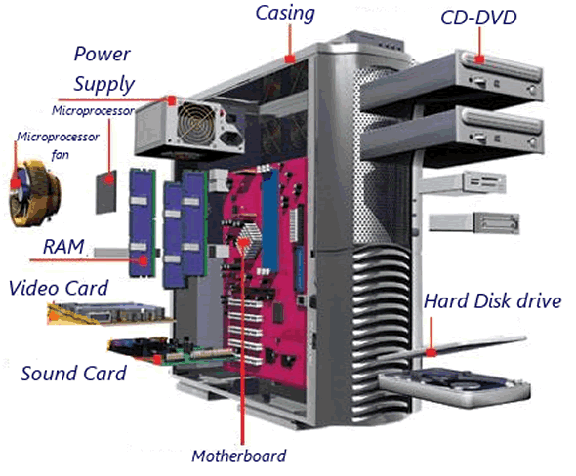

**Core Components:**

1. **Central Processing Unit (CPU)**: The brain of the computer where most calculations take place. It's responsible for executing instructions and managing tasks.

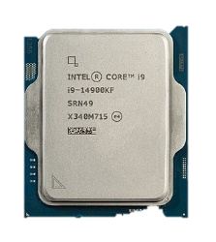

Fig: A modern consumer CPU made by [Intel](https://en.wikipedia.org/wiki/Intel): An [Intel Core i9-14900KF](https://en.wikipedia.org/wiki/Intel_Core_i9-14900KF)

*The CPU itself is made of three components:*

1. Arithmetic Logic Unit (ALU),

2. Memory Unit, and

3. Control Unit.

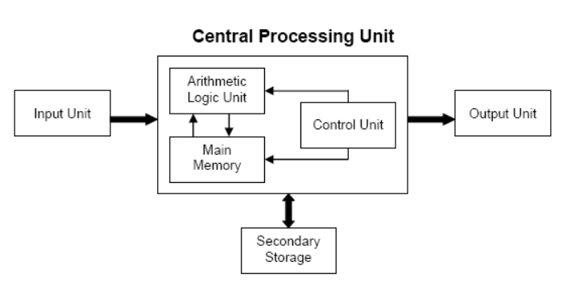

Fig: block diagram of central processing unit

On broad basis, a computer performs the following tasks:

**Input**: Sending the data and command to the computer is known as input.

**Processing**: Work done by the computer with the help of processing hardware and software to produce results is known as processing.

**Output**: The result displayed by the computer is known as output.

**Storage**: A place to save result inside or outside the computer is known as storage.

1. **Motherboard**: A motherboard is one of the most essential parts of a computer system. It holds together many of the crucial components of a computer, including the central processing unit (CPU), memory and connectors for input and output devices. In addition to circuits, a motherboard contains a number of sockets and slots to connect the other components.

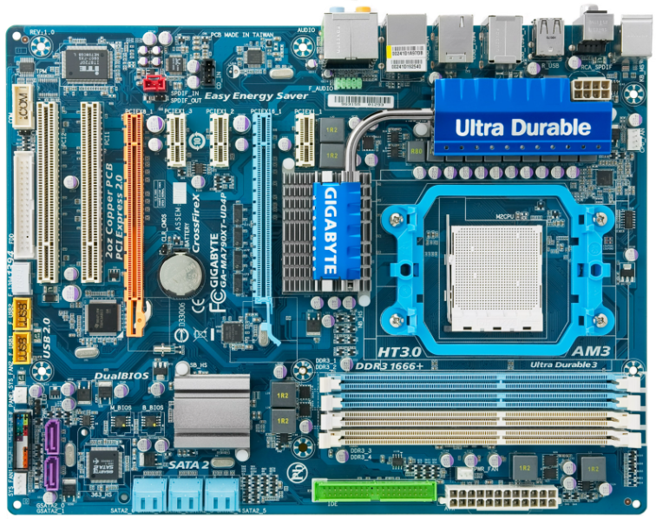

Fig: Motherboard

1. **Memory (RAM)**: Random Access Memory is the short-term memory of the computer, used for storing data that is actively being used or processed.
2. **Storage**: There are two main types:
   * **HDD (Hard Disk Drive)**: Uses magnetic storage to store and retrieve data.
   * **SSD (Solid State Drive)**: Uses flash memory for faster data access and retrieval.
3. **Power Supply Unit (PSU)**: Converts electrical energy from an outlet into a usable form for the computer. It's the heart that pumps power to every component.
4. **Graphics Processing Unit (GPU)**: Handles rendering images, videos, and animations. It's especially important for gaming, video editing, and other graphics-intensive tasks.

**Peripheral Components:**

1. **Monitor**: The screen that displays visual output from the computer.
2. **Keyboard and Mouse**: Input devices that allow you to interact with the computer.
3. **Speakers and Microphone**: Audio input and output devices for sound.
4. **External Hard Drive**: An external hard drive is a larger, portable storage device that connects to a computer via a USB, Thunderbolt, or other ports.
5. **USB Flash Drive**A USB flash drive is a small, portable storage device that connects to a computer via a USB port.

**Connectivity:**

1. **Network Interface Card (NIC)**: Connects the computer to a network (wired or wireless).
2. **USB Ports**: For connecting various peripherals like printers, external drives, and more.

**Memory**

Computer memory is just like the human brain. It is used to store data/information and instructions. It is a data storage unit or a data storage device where data is to be processed and instructions required for processing are stored. It can store both the input and output can be stored here.

*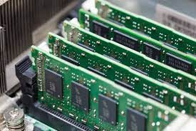In general, memory is of three types:*

* Primary memory
* Secondary memory
* Cache memory

**1. Primary Memory:** It is also known as the main memory of the computersystem. It is used to store data and programs or instructions during computer operations. It uses semiconductor technology and hence is commonly called semiconductor memory.

Primary memory is of two types:

* **RAM (Random Access Memory)**: RAM, or **Random Access Memory**, is a crucial component of any computer system. It provides space for your computer to read and write data to be accessed by the CPU quickly. It is volatile, meaning it loses its data when the power is turned off.

Here are the main types of RAM:

* **SRAM (Static RAM)**: This type of RAM is fast and costly. It uses flip-flops to store each bit of memory and does not need to be refreshed constantly.
* **DRAM (Dynamic RAM)**: More common and less expensive than SRAM, DRAM stores each bit of data in a separate capacitor within an integrated circuit and requires periodic refreshing.
* **SDRAM (Synchronous DRAM)**: This type synchronizes with the system clock, allowing for faster data access.
* **DDR SDRAM (Double Data Rate SDRAM)**: An advancement over SDRAM, DDR can transfer data twice per clock cycle. There are several generations of DDR, each offering increased speed and efficiency:

1. 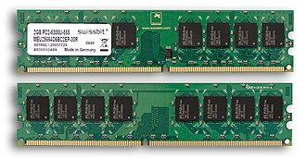DDR1
2. DDR2
3. DDR3
4. DDR4
5. DDR5

* **ROM (Read-Only Memory)**: Permanent storage that typically contains the system's firmware. It is a type of non-volatile memory used in computers and other electronic devices. Unlike RAM, which loses its data when the power is turned off, ROM retains its data permanently, even without power. This makes ROM ideal for storing firmware, which is the software that is closely tied to specific hardware and rarely needs to be updated.

Here are the main types of ROM:

1. **MROM (Masked ROM)**: The original form of ROM, MROM is programmed during the manufacturing process and cannot be altered. It's used for applications where the data or code does not need to change.
2. **PROM (Programmable ROM)**: PROM can be programmed by the user after manufacturing, but only once. This type of ROM is used for applications where customization is required, but changes are infrequent.
3. **EPROM (Erasable Programmable ROM)**: EPROM can be erased by exposing it to ultraviolet light and then reprogrammed. This provides flexibility for development and testing purposes.
4. **EEPROM (Electrically Erasable Programmable ROM)**: EEPROM can be erased and reprogrammed using electrical signals. This type of ROM allows for more convenient and frequent updates compared to EPROM. It's commonly used in devices like microcontrollers and BIOS chips.
5. **Flash Memory**: A type of EEPROM, flash memory can be erased and reprogrammed in blocks, making it faster and more efficient for larger data storage. It's widely used in SSDs, USB drives, and memory cards.

Each type of ROM has its own advantages and use cases. For example, Flash Memory is popular for its speed and capacity, while MROM is used when permanent storage with no need for updates is required.

* **Cache memory**: Cache memory is a special type of memory used to speed up data access by storing frequently accessed data and instructions close to the CPU.

**Ports**

* **USB Ports (Universal Serial Bus)**: Used for connecting a wide range of peripherals like keyboards, mice, and external storage devices.
* **HDMI (High-Definition Multimedia Interface)**: Used for transmitting audio and video signals to monitors and TVs.
* **Power supply plug in:** The Power supply, as its name implies, provides the necessary electrical power to make the pc operate. the power supply takes standard 110-V AC power and converts into 12-Volt, 5-Volt, and 3.3-Volt DC power.
* **Ethernet Port**: For wired internet connections.
* **Audio Jacks**: For connecting headphones, microphones, and speakers.
* **VGA port**: It is a 15-pin connector that transmits analog video signals from a computer to a display device such as a monitor or projector.
* **Firewire Port:** Used for high-speed data transfer, commonly in video cameras and external drives.
* **Thunderbolt**: Combines data transfer, video output, and power supply in one interface.

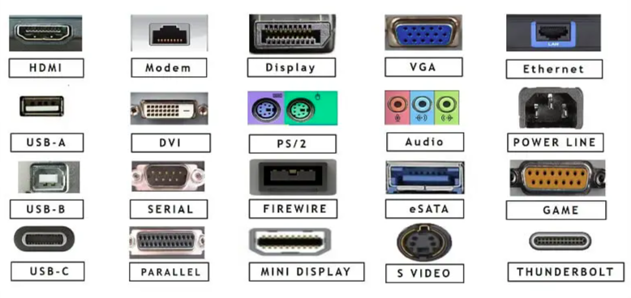

Fig: Different types of ports

**Motherboard**

* **CPU Socket**: The slot where the processor is installed.

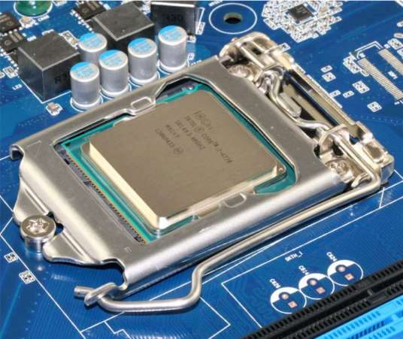

Fig: CPU socket

* **Cooling System:** Fans and Heat Sinks: Keep the temperature down by dissipating heat generated by the CPU and GPU.
* **RAM Slots**: Where the memory modules are inserted.
* **PCIe Slots**: Expansion slots for graphics cards, sound cards, and other add-on cards.
* **Chipset**: Controls data flow between the CPU, memory, and peripherals.
* **BIOS/UEFI Chip:** A chip that stores the Basic Input/Output System (BIOS) or Unified Extensible Firmware Interface (UEFI). It Initializes hardware components during boot-up and provides runtime services for operating systems and programs.
* **North Bridge**: Northbridge is located in the northern section of the motherboard. It is also known as the host bridge. It is directly connected to the CPU, RAM, AGP, and PCI Express slots. If it is required for the CPU to communicate with AGP or PCI express slots etc., the communication occurs via the northbridge. Usually, northbridge operates at a faster speed as it connects to high-speed components in the computer.
* **South Bridge:** Southbridge is located in the southern section of the motherboard. It connects the components such as PCI bus slots, BIOS, IDE connectors and USB ports. There is no direct connection between the CPU and the southern section of the motherboard. If components like PCI, USB etc. need to communicate with the CPU, the information has to go through the southbridge, then northbridge and finally to the CPU.

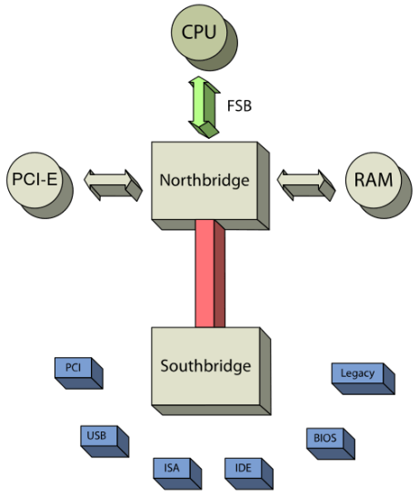

Fig: Block diagram of north and south bridge.

* **CMOS Battery:** To provide CMOS with the power when the computer is turned off all motherboards comes with a battery. These batteries mount on the motherboard in one of three ways: the obsolete external battery, the most common onboard battery, and built-in battery.
* **AGP slot:**  If you have a modern motherboard, you will almost certainly notice a single connector that looks like a PCI slot, but is slightly shorter and usually brown. You also probably have a video card inserted into this slot. This is an *Advanced Graphics Port (AGP)* slot.
* **Jumpers:** Jumpers on a motherboard are small pins that can be covered with a plastic block (often called a jumper block) to close an electrical circuit. They are used to configure hardware settings manually

**Add-on Cards**

Add-on cards, also known as expansion cards, are hardware components that can be inserted into expansion slots on a computer motherboard to enhance its capabilities. Here are some common types of add-on cards and their functions:

**1. Graphics Card (GPU)**

* **Definition**: A graphics processing unit that enhances the computer's ability to render images, videos, and animations.
* **Function**: Provides better graphics performance for gaming, video editing, and other graphics-intensive tasks.

**2. Sound Card**

* **Definition**: A dedicated audio processing unit that improves the quality of sound output.
* **Function**: Enhances audio performance for activities like music production, gaming, and media playback.

**3. Network Interface Card (NIC)**

* **Definition**: A card that enables a computer to connect to a network (wired or wireless).
* **Function**: Provides network connectivity for accessing the internet or a local network.

**4. RAID Controller Card**

* **Definition**: A card that manages multiple hard drives configured in a RAID (Redundant Array of Independent Disks) setup.
* **Function**: Improves data storage performance and reliability by combining multiple drives into a single logical unit.

**5. USB Expansion Card**

* **Definition**: A card that adds additional USB ports to a computer.
* **Function**: Increases the number of available USB ports for connecting more devices.

**6. Wi-Fi Card**

* **Definition**: A card that enables wireless network connectivity.
* **Function**: Provides Wi-Fi capabilities for accessing wireless networks.

**7. TV Tuner Card**

* **Definition**: A card that allows a computer to receive television signals.
* **Function**: Enables the computer to function as a TV and record television broadcasts.

**8. Capture Card**

* **Definition**: A card that allows the computer to capture video and audio from external sources.
* **Function**: Used for recording or streaming video from devices like gaming consoles and cameras.